**E2E Opportunity Case Study**

**Automate the following steps using Selenium**

**Step 1 : Login to SFDC**

**Step 2 : Navigate to Accounts Tab and click on New button**

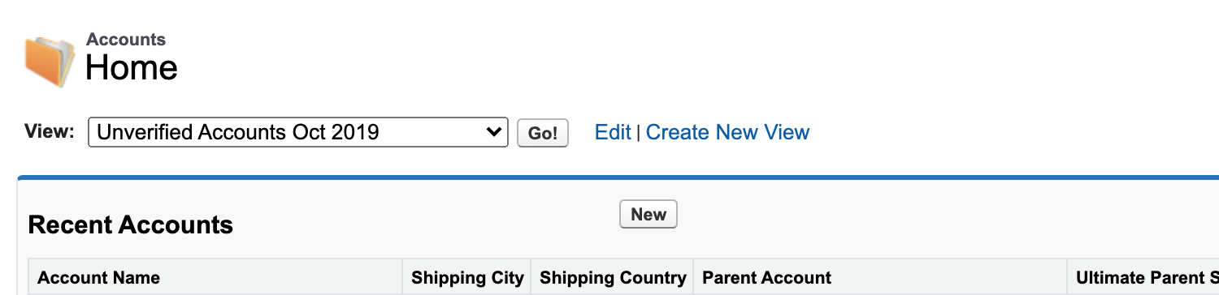

**Step 3 : Enter mandatory fields and create an account ( Add a step to verify that correct error message is shown on not entering mandatory fields)**

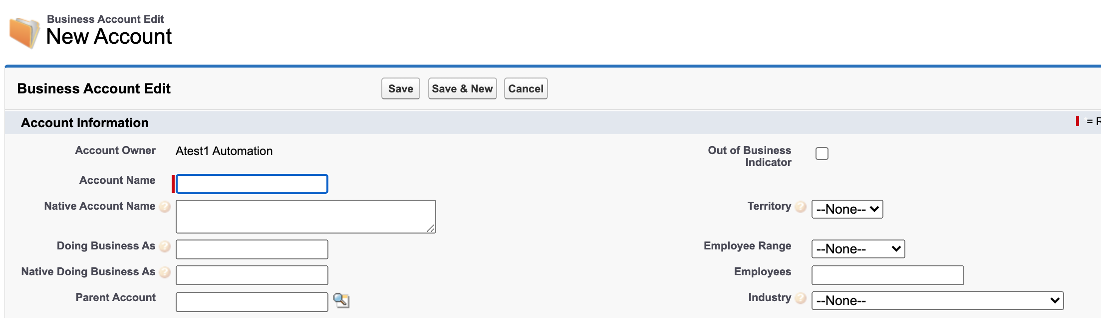

**Step 4: Go to the Contacts related list and click on New Contact**



**Step 5 : Enter required fields and create the contact (Add a step to verify that correct error message is shown on not entering mandatory fields)**

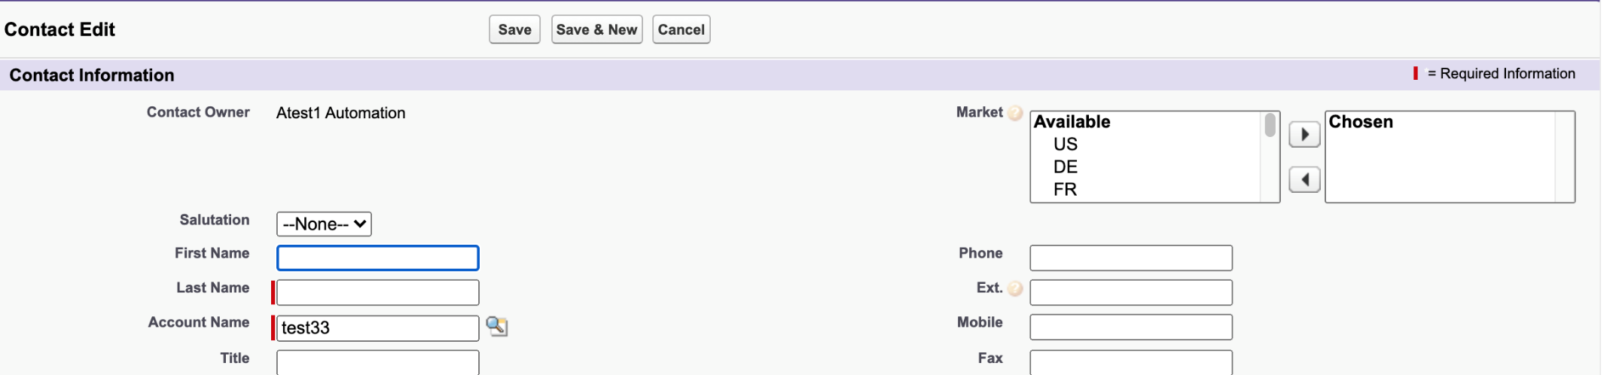

**Step 6: Go to Opportunities tab and create a new opportunity. Select the above created account for the opportunity. Enter the mandatory fields.**

**(Note - Make sure to automate all types of fields like PickList, Multi value picklist, look up etc)**

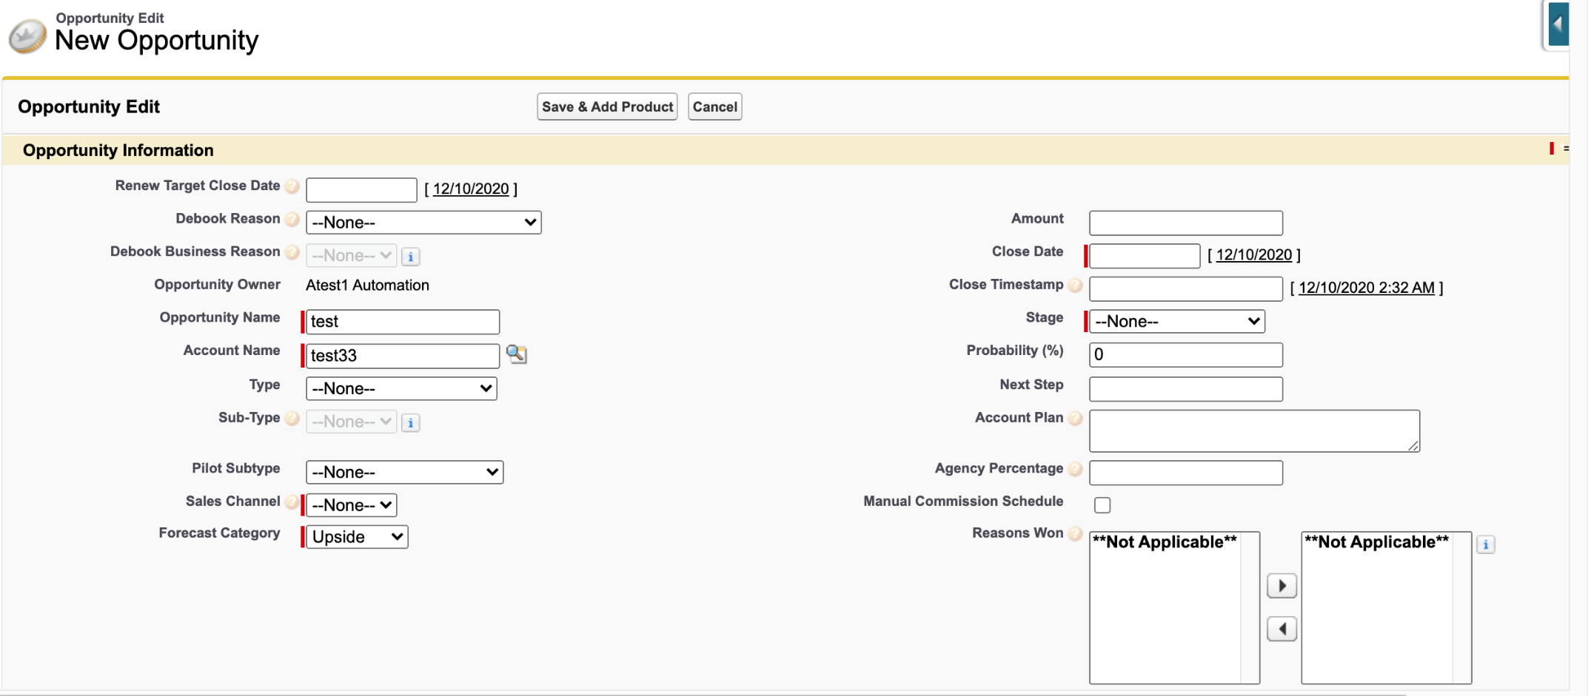

**Step 7: Add Products and Contact Roles to the opportunity**

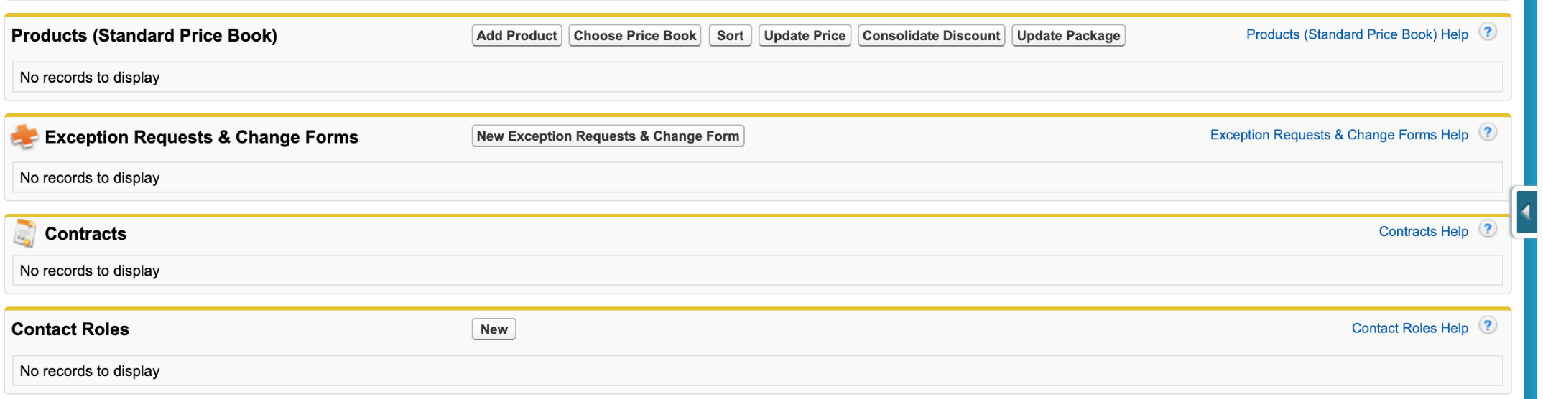

**Step 8 : Add a task and an event and Attach a file to the opportunity**

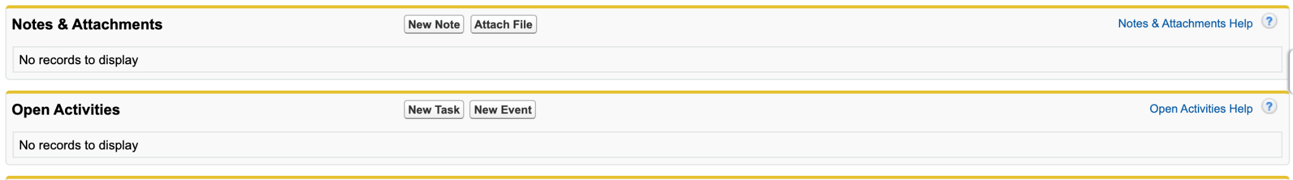

**Step 9 : Change the stage of the opportunity to Closed Won without changing status of open activities to ‘Done’. Verify that error message is shown mentioning that the open activities should be completed before closing the opportunity**

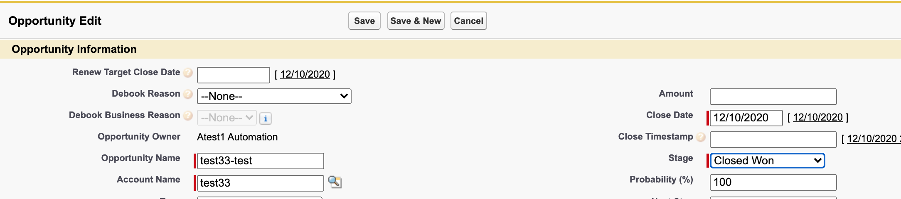

**Step 10: Change the status of open activities to Done and then change Stage of opportunity to Closed Won. Verify that opportunity is Closed.**